Q1

Q2

Q3

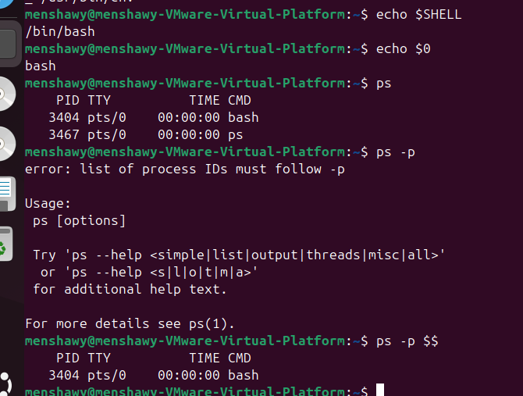

Q4

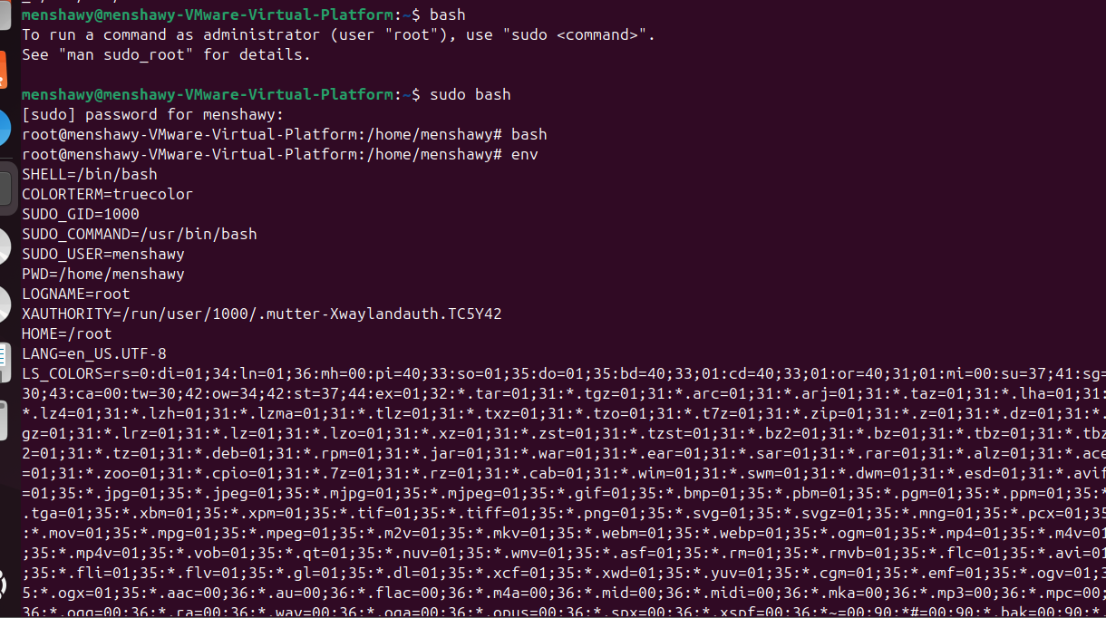

Q5







Q6

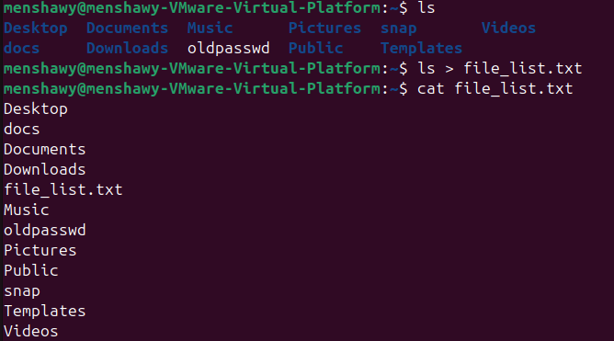

Q7



Q8

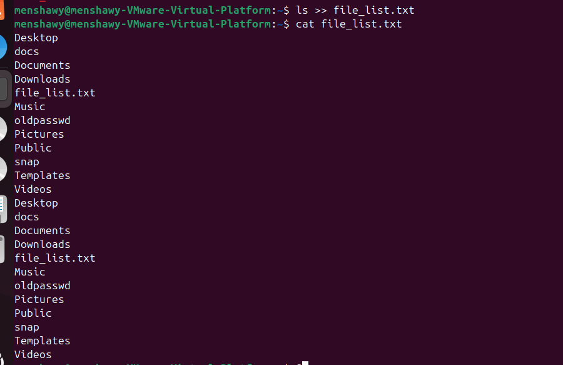

Q9

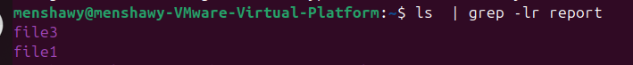

Q10

Q11

Q12

Q13

Q14



Q15

Q16

Q17

Q18

Q19



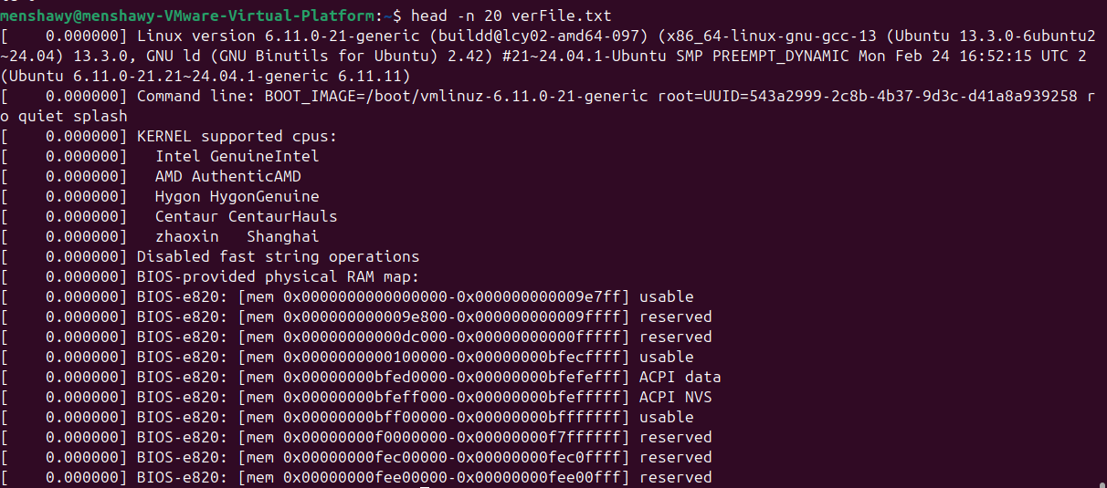

Q20

